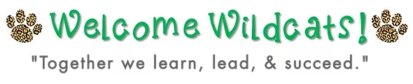
Drive by Meet and Greet and Supply Drop Off
Thursday, August 6 for 1st-5th grades
9:00-10:00 1st grade
10:15-11:15 2nd grade
12:15-1:15 3rd grade
1:30-2:30 4th grade
2:45-3:45 5th grade

Friday, August 7 for Pre-K
10:00-11:00

Tuesday, August 11 for K
1:30-2:30

Parent Info:
- Drop off at the front of the school.
- One adult may get out the car to place supplies on table. Teachers will be there to assist.
- Make sure all supplies are labeled with child’s first and last name.
- Masks are encouraged.

Roaring Into the 2020-2021 School Year!

Walker Elementary Parent and Student Info

Together we can commit to following the safety guidelines outlined below to protect your child, their peers, and their teachers. Please expect these procedures and prepare your child.
Students

GETTING READY AND TO SCHOOL SAFELY:
- Before I come to school, I will check my temperature and assess my symptoms; if I have a fever of 100.4 or higher, or a cough, shortness of breath, or loss of taste or smell, or if I have been in direct contact with someone who has COVID-19, I will stay home and contact my medical provider.

- When waiting for the bus, I will practice social distancing and wear my face covering.

- I will use hand sanitizer as I board the bus, and on the bus, I will wear my face covering and sit where assigned. My bus will be cleaned between routes.

- If I ride in a car to school, my parent or guardian will drop me off in the car rider area; parents will not be able to walk me to my classroom. I will wear a mask upon entering the school.

- If I ride in a car to school, my temperature will be checked at my car. My parents will wait and if I have a temperature, be taken back home.

- If I arrive to school after the tardy bell rings, I will follow the directions posted on the front door.

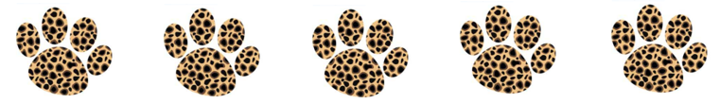

Students

SAFETY AT SCHOOL:
- When I arrive at school, I will have my temperature checked by staff. I will wear my face covering, pick up my grab-and-go breakfast, and report to my classroom.

- I am encouraged to come to school daily with a mask, hand sanitizer, water bottle, and earbuds (and not sharing them). Labeling these items with my first and last name is very important.

- I will bring a labeled water bottle to school, as water fountains will be closed for regular use; water fountains may only be used to refill water bottles throughout the day.

- When I am moving about the classroom and in hall, I will wear my face covering and practice social distancing.

- When I am in the classroom, I may remove my face covering when working independently at my desk or when the teacher is providing whole group instruction. I will wear my face covering when working in small groups with the teacher or my peers. I will use my own headphones/earbuds for computer stations, and I will use hand sanitizer before and after I complete my computer tasks. Desks, tables, and computer stations will be spaced safely apart.

- I will wash my hands frequently or use hand sanitizer throughout the day.

- When I am changing classes or going to a special area class, I will wear my mask and practice social distancing. I will follow one-directional signs in hallways.

- In the cafeteria, I will wear my face covering when waiting in line for food, and I will practice social distancing. Before picking up my food, I will wash my hands. Seating will be staggered for safety. I may remove my mask while eating, but will put my mask back on before leaving the table.

Parents and Students

SAFETY PROCEDURES FOR EVERYONE:
- Access to campus will be limited to students and staff members only.

- No cash will be accepted during phase 2. All fees/money will be paid online at http://osp.osminc.com/LivingstonLA/ .

- Students will remain with their classmates all day; special area teachers will travel to them, when possible. (Students receiving special education and/or speech services, etc.) Groups will stay static as much as possible. Classrooms will be cleaned between transitions.

- It is very important to label your child’s items with their first and last name. There will no Lost and Found. Any unlabeled items left will be thrown in the trash nightly.

- Temperature checks will be conducted upon entry each day so that all students and staff members have their temperature checked daily.

- Parents who are checking their child out (due to illness or medical appointment) will follow the procedures posted on the front door. A staff member and your child will meet you at the door, check your identification, and assist you in signing out the student. Checkouts are not allowed within the last 30 minutes of the regular end of the school day. (No checkouts allowed after 2:45). Only parents, guardians, or other individuals identified on the student’s contact list, with appropriate identification, will be allowed to leave with the student.

- There will be a designated isolation area in the event that a child or a staff member comes to school and presents COVID-19 symptoms. Parents will be contacted to pick ill students up immediately. Ensure the office has a valid/updated contact number on file. Contact tracing will be used to identify students or staff members who may need to self-quarantine for 14 days.
Students will transition to digital learning during the self-quarantine period using the Google Classroom platform.

- Children need one mode of transportation to and from school, switching transportation modes will NOT be allowed due to contact tracing difficulty.

- All buildings and work spaces will be cleaned nightly.

- On days students are physically on campus, teachers will provide assignments to be completed online using a digital platform, or students will join the live class remotely. Instruction will be a combination of synchronous learning (teacher-led) and asynchronous learning (self-paced).

- Students in Pre-K-2nd grade will follow a traditional model with 5 days of face to face instruction. Students in grades 3rd-5th will follow an AB hybrid model with mix of face to face and virtual instruction.

